**Chapter 6**

**Vector Calculus**

**6.5 Divergence and Curl**

**Section Exercises**

**For the following exercises, determine whether the statement is *true or false*.**

1. If the coordinate functions of  have continuous second partial derivatives, then  equals zero.

Answer: False

1. 

Answer: False

1. All vector fields of the form  are conservative.

Answer: True

1. If  then **F** is conservative.

Answer: True

1. If **F** is a constant vector field then 

Answer: True

1. If **F** is a constant vector field then 

Answer: True

**For the following exercises, find the curl of F.**

1. 

Answer: 

1. 

Answer: 

1. 

Answer: 

1. 

Answer: 

1. 

Answer: 

1. 217. 

Answer: 

1. 

Answer: 

1. 219. 

Answer: 

1. 

Answer: 

1.  for constants *a*, *b*, *c*

Answer: 

**For the following exercises, find the divergence of F.**

1. 

Answer: 

1. 

Answer: 

1. 

Answer: 

1. 

Answer: 

1. 

Answer: 

1. 

Answer: 

1. 

Answer: 

1.  for constants *a*, *b*, *c*

Answer: 

1. 

Answer: 

1. 

Answer: 

**For the following exercises, determine whether each of the given scalar functions is harmonic.**

1. 

Answer: Harmonic

1. 

Answer: Harmonic

1. If  and , find 

Answer: 

1. If  and  find 

Answer: 

1. Find , given that , where 

Answer: 

1. Find the divergence of **F** for vector field .

Answer: 

1. Find the divergence of **F** for vector field .

Answer: 

**For the following exercises, use  and **

1. Find the 

Answer: 

1. Find the

Answer: 

1. Find the

Answer: 

1. Let  where **F** is defined on  Find .

Answer: 

**For the following exercises, use a computer algebra system to find the curl of the given vector fields.**

1. **[T]** 

Answer: 

1. **[T]** 

Answer: 

**For the following exercises, find the divergence of F at the given point.**

1.  at 

Answer: 

1.  at 

Answer: 

1.  at 

Answer: 

1.  at (1, 2, 1)

Answer: 

1.  at (0, 0, 3)

Answer: 

**For the following exercises, find the curl of F at the given point.**

1.  at 

Answer: 

1.  at 

Answer: 

1.  at (3, 2, 0)

Answer: 

1.  at (1, 2, 1)

Answer: 

1.  at (0, 0, 3)

Answer: 

1. Let  For what value of *a* is **F** conservative?

Answer: 

1. Given vector field  on domain  is **F** conservative?

Answer: **F** is not conservative.

1. Given vector field  on domain  is **F** conservative?

Answer: **F** is conservative.

1. Find the work done by force field  in moving an object from *P*(0, 1) to *Q*(2,0). Is the force field conservative?

Answer: W = 2, yes

1. Compute divergence 

Answer: 

1. Compute curl 

Answer: 

**For the following exercises, consider a rigid body that is rotating about the *x*-axis counterclockwise with constant angular velocity  If *P* is a point in the body located at  the velocity at *P* is given by vector field** 

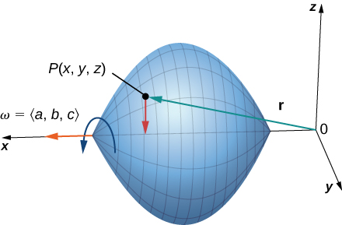

1. Express **F** in terms of **i**, **j**, and **k** vectors.

Answer: 

1. Find 

Answer: 

1. Find 

Answer: 

**In the following exercises, suppose that  and **

1. Does  necessarily have zero divergence?

Answer:  does have zero divergence.

1. Does  necessarily have zero divergence?

Answer: does not have zero divergence.

**In the following exercises, suppose a solid object in  has a temperature distribution given by  The heat flow vector field in the object is  where  is a property of the material. The heat flow vector points in the direction opposite to that of the gradient, which is the direction of greatest temperature decrease. The divergence of the heat flow vector is **

1. Compute the heat flow vector field.

Answer: 

1. Compute the divergence.

Answer: 

1. **[T]** Consider rotational velocity field  If a paddlewheel is placed in plane  with its axis normal to this plane, using a computer algebra system, calculate how fast the paddlewheel spins in revolutions per unit time.

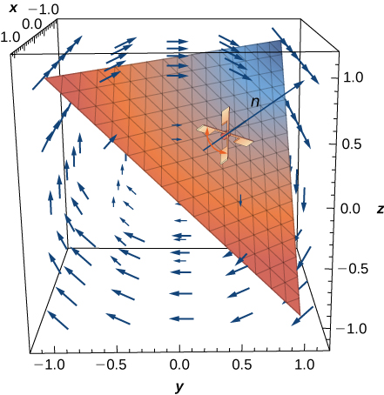

Answer: 

This file is copyright 2016, Rice University. All Rights Reserved.